- Understanding the “freeRTOSConfig.h” file.
  - PATH of file: vi $(HOME)/<Project/ApplicationName>/esp/esp-idf/components/freertos/config/include/freertos/FreeRTOSConfig.h
  - FreeRTOS is customised using a configuration file called FreeRTOSConfig.h.
  - Every FreeRTOS must have this file in the preprocessor PATH.
    - heap size
      - #define configTOTAL_HEAP_SIZE 10240
      - It gives the total amount of RAM available in the FreeRTOS heap.
    - stack size
      - #define configMINIMAL_STACK_SIZE 128
      - The size of the stack used by the idle task.
      - The stack size is specified in words, not bytes.
      - If each item placed on the stack is 32 bits, then a stack size of 100 means 400 bytes (each 32-bit stack item consuming 4 bytes).
    - CPU clock
      - #define configCPU_CLOCK_HZ 60000000
      - frequency in Hz
      - The internal clock that drives the peripheral used to generate the tick interrupt will be executing
      - The same clock drives CPU clock
      - For configuring timer peripherals correctly, a clock value must be given.
    - tick rate
      - #define configTICK_RATE_HZ 250
      - The frequency of the RTOS tick interrupt.
  - Link: freeRTOSConfig.h
  - It has Memory-allocated definitions, Tick Rate, Hook function-related definitions, and Software Timer Related definitions.
- Understanding Critical sections for ARM cortex FreeRTOS ports
  - Available Priority Levels
    - Cortex-M hardware details
      - Priorities are set by manufacturer that uses the ARM Cortex-M core, So, all ARM cortex have the same number of unique interrupt priorities
      - Allows Max 265 (8 bits - 0 to 0xff) different priorities from which some of them are allowed to use.
    - Relevance when using the RTOS
      - Two groups
        - that will get masked by RTOS critical sections
        - that are never masked by RTOS critical sections and are therefore always enabled.
      - configMAX_SYSCALL_INTERRUPT_PRIORITY defines the boundary between the above 2 groups.
  - Preempt Priority and Subpriority
    - Cortex-M hardware details
      - The 8-bit priority register is divided into two parts
        - preempt priority
          - defines whether an interrupt can preempt an already executing interrupt.
        - sub priority
          - determines which interrupt will execute first when two interrupts of the same preempt priority occur at the same time
    - Relevance when using the RTOS
      - It is recommended to assign all the priority bits to be preempt priority bits, leaving no priority bits as subpriority bits
  - Inverse Relationship Between Numeric Priority Value and the Logical Priority Setting
    - Cortex-M hardware details
      - 2 interrupts have been given priority levels as 2 and 5
      - The High priority is given to 2 levels and Low priority is given to 5 level
    - Relevance when using the RTOS
      - configMAX_SYSCALL_INTERRUPT_PRIORITY is defined in the FreeRTOSConfig.h header file
      - ISR define in RTOS API >= configMAX_SYSCALL_INTERRUPT_PRIORITY setting
      - To ensure interrupt logical priority <= configMAX_SYSCALL_INTERRUPT_PRIORITY
  - Cortex-M Internal Priority Representation
    - Cortex-M hardware details
      - ARM Cortex-M stores interrupt priorities in MSB of 8 bit interrupt priority.
      - Below image shows the detail for the same.
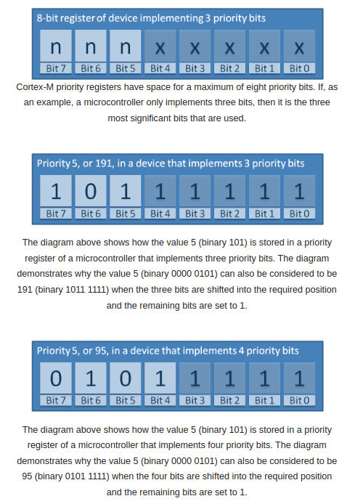

    - Relevance when using the RTOS
      - set by the configMAX_SYSCALL_INTERRUPT_PRIORITY
  - Critical Sections
    - Cortex-M hardware details
      - ARM Cortex-M core's BASEPRI register.
      - This allows the RTOS kernel to only mask a subset of interrupts, and therefore provide a flexible interrupt nesting model.
      - BASEPRI is a bit mask
    - Relevance when using the RTOS
      - The RTOS kernel creates a critical section by writing the configMAX_SYSCALL_INTERRUPT_PRIORITY value into the ARM Cortex-M BASEPRI register. As priority 0 interrupts (the highest priority possible) cannot be masked using BASEPRI, configMAX_SYSCALL_INTERRUPT_PRIORITY must not be set to 0.
- Hook Function
  - Hook Function Link
  - Idle Hook Function
    - void vApplicationIdleHook( void );
    - The idle hook will only get called if configUSE_IDLE_HOOK is set to 1 within FreeRTOSConfig.h.
    - An idle task can be called the Idle Hook Function.
    - The idle task can run at the lowest priority. Idle tasks are run when no higher-priority task is available.
  - Tick Hook Function
    - void vApplicationTickHook( void );
    - It provides a convenient place to implement timer functionality.
    - The Tick Hook function is called only if ConfigUse_Tick_Hook is set to 1 in freeRtosconfig.h
  - Malloc Failed Hook Function
    - Implementing Malloc Failed Hook function will identify the problem caused by lack of heap memory.
    - Malloc Failed Hook is called only if ConfigUse_Malloc_Failed_Hook is set to 1 in FreeRTOSConfig.h.
    - heap_1.c, heap_2.c, heap_3.c, heap_4.c and heap_5.c
      - heap_1 - the very simplest, does not permit memory to be freed.
      - heap_2 - permits memory to be freed, but does not coalescence adjacent free blocks.
      - heap_3 - simply wraps the standard malloc() and free() for thread safety.
      - heap_4 - coalescences adjacent free blocks to avoid fragmentation. Includes absolute address placement option.
      - heap_5 - as per heap_4, with the ability to span the heap across multiple non-adjacent memory areas.
    - void vApplicationMallocFailedHook( void );
  - Stack Overflow Hook Function
    - Stack Overflow Protection
  - Daemon Task Startup Hook
    - It allows initialization code before use of RTOS functionality.
    - same as the Timer Service Task.
    - Daemon Task StartUp Hook is called only if ConfigUse_Daemon_Task_startUp_Hook is set to 1 in FreeRTOSConfig.h
    - void vApplicationDaemonTaskStartupHook( void );
- The attached code is an example of the below parameters
  - Heap Size
  - Stack Size

